Create a free talking avatar with Voki
1) visit www.voki.com
2) follow the online instructions to create an account
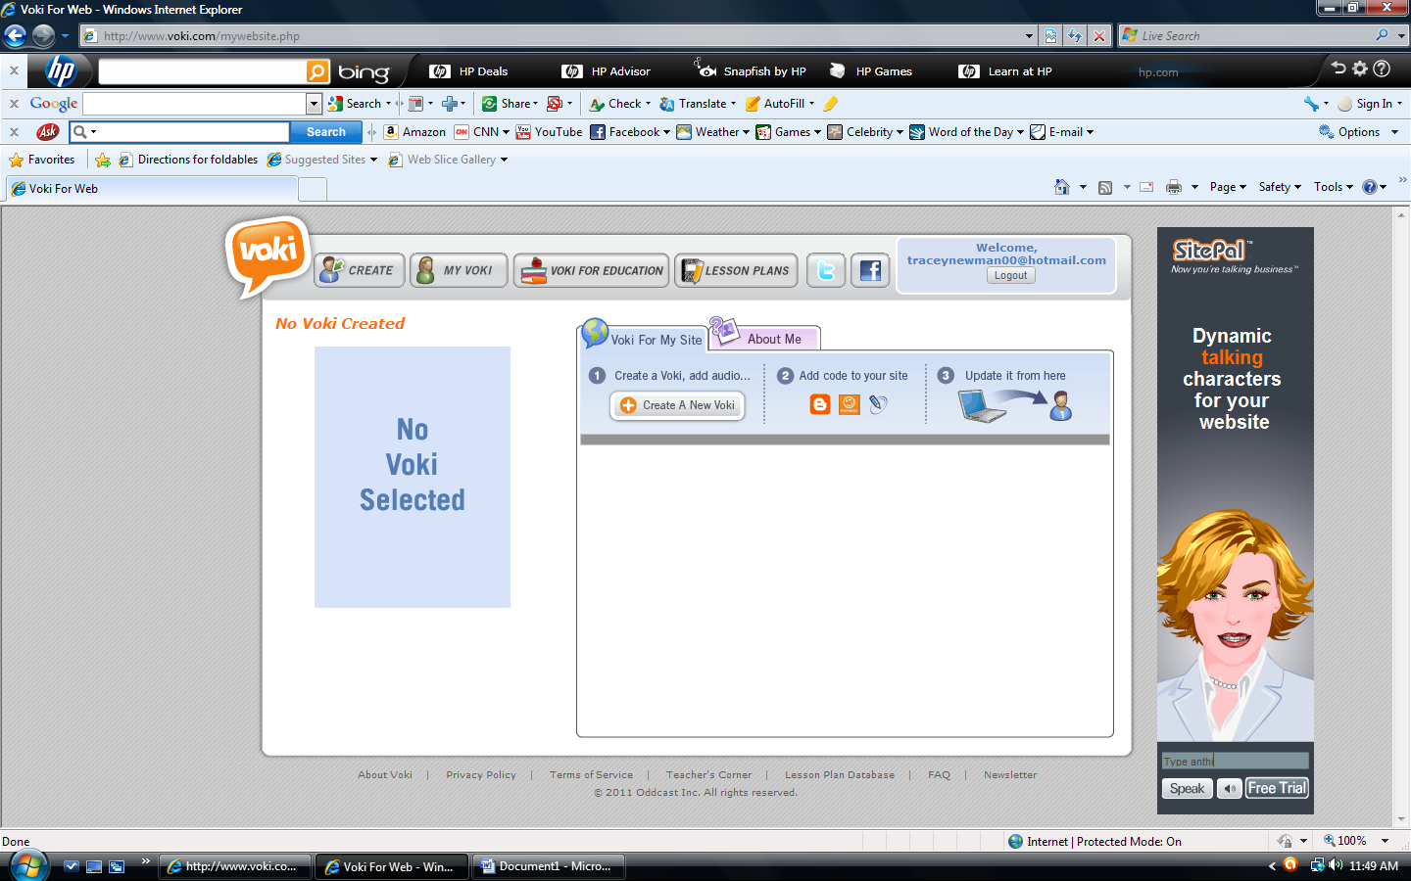
3) click "create"
4) To change the appearance of the avatar, experiment with any of the three boxes under "customize your character"
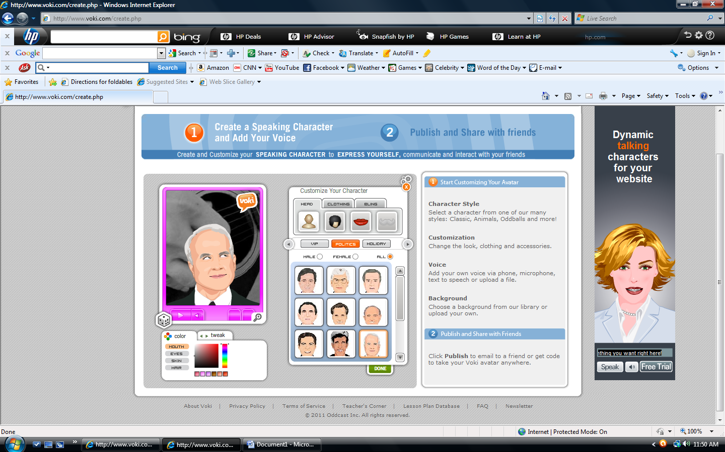
5) There are many options available including characters in several categories. In addition to choosing a character, hairstyles and facial feature may be changed, and accessories can be added to the voki.
6) The colors of all of these elements may be changed with the box in the lower left of the screen.
7) At any time, clicking the die on the left will cause the voki to randomize.
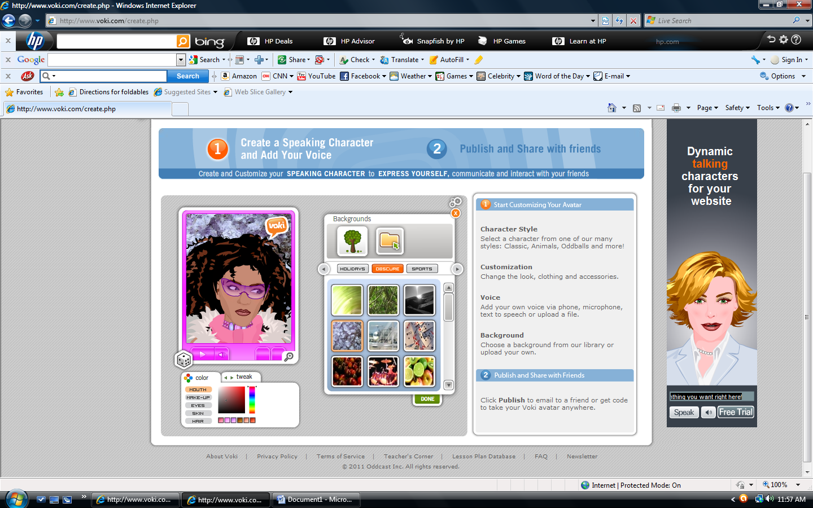
8) When finished creating the appearance of your voki, click "done"
9) Click "backgrounds" to change the scenery behind the voki.

10) For advanced users, a file may be uploaded for the background.
11) When finished with the background, click "done".
12) To change the border around the voki, click "players" and choose the style and color.

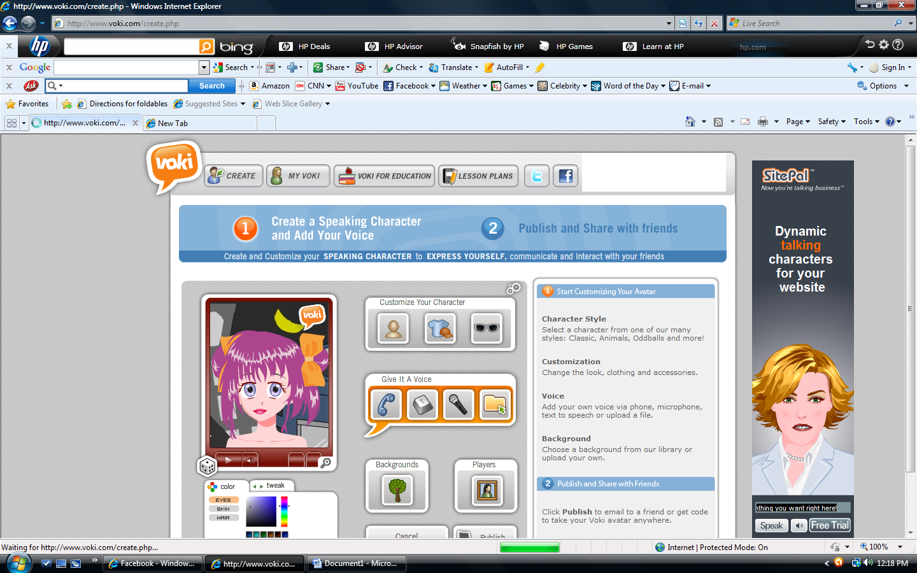

13) To add sound, click "give it a voice" and experiment with the options available for the voki voice.
The telephone icon offers the option of recording your own voice via telephone call
The text key offers the option of typing the words into the computer and choosing a voice
The microphone allows recording of a person's voice into the voki
The file option allows uploading of an audio file
When the message has been completed, click "done"
14) Click "publish" and name the voki.
15) The voki may now be uploaded to many popular social media sites or the code may be copied and embedded into another site. Another option is sharing the voki with an email to a specific person.

