Glogster

Setting up an account:
- Go to www.glogster.com
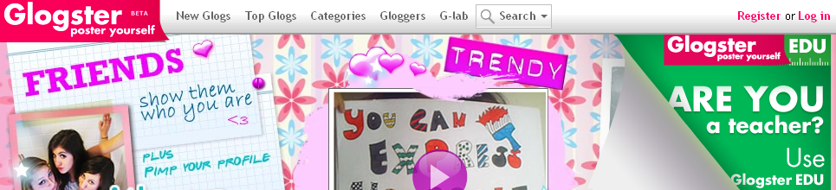
- Click on the EDU in green

- A new screen will appear and choose the EDU Basic
- Click on “Start with Basic”
- Fill out the registration
- Be sure and write down your nickname & password

How to create a Glogster:
- Go to www.glogster.com
- Log in with the nickname and username you create above
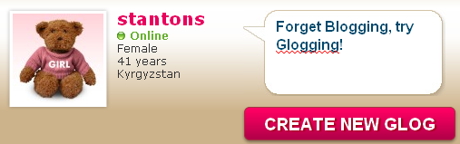
- Click on Create New Glog

- The Glog will appear and it is ready to be created

Hints to Navigate the Glog
- Hover over objects and a tool bar will appear (then it can be deleted)
- Images and text boxes are similar to text boxes in word
  - Click on the edge of an image/text box and it will change the size
- The magnet tool on the left hand side is how images, texts, wall design, videos, and music can be added
  - Once you click on the topic you would like a screen pops up with options
  - Click on “use it” to add it to the glogster
- If the magnet tool disappears click on the pink box that is on the left hand side bar
- Click save in the top right hand corner often

Teacher tips with Glogster:
- Have students save often
- For collage about me have students start by going to Google Images and saving images that they feel represent their needs, wants, values, goals and save them to their desktop or a flash drive. This allows for faster creation of the glogster.
- Allow students notice a day in advance of the “Collage about Me” activity so students can load personal pictures.
- Have students log in with your “teacher account” so that you have a record of what they have done
- Request for students to complete all requirements of collage about me before decorating the Glogster. For instance ask them to list their wants, needs and goals before adding sounds or changing the “wall design”. This ensures students are focused on the purpose of the lesson not the technology.
- When students log in as you there uploaded videos, sounds and images stay in your account options; therefore you may want to periodically clear out your Glogster images, sounds, videos, etc.

