How to get started in creating your own Free Weebly
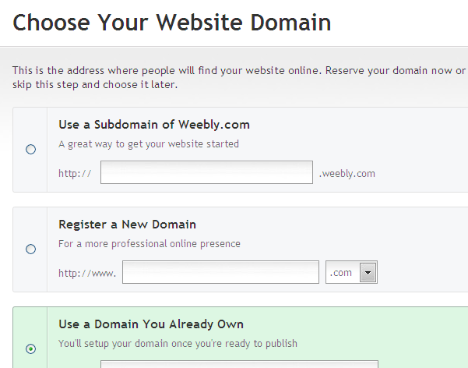

- Go to www.weebly.com
- Sign Up
- At the pop screen name your site
- Choose the categories for your site
- Press continue
- At the “choose your domain” pop up
  - Select the first box
  - Name your webpage
  - Be sure it’s available
  - Scroll down & press continue
- Choose your page design
  - Click on the design tab
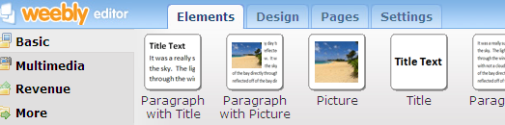

  - Choose your design
- Add pages
  - Click on the Pages tab
  - Click on New Page
  - Type the name of your new page
  - Press Save
- Use the elements tab to add text, pictures, html widgets and more
- Have fun!

