Make Beliefs Comix
- Go to http://www.makebeliefscomix.com/
- Click on Enter Here
- Name your comic & put your name
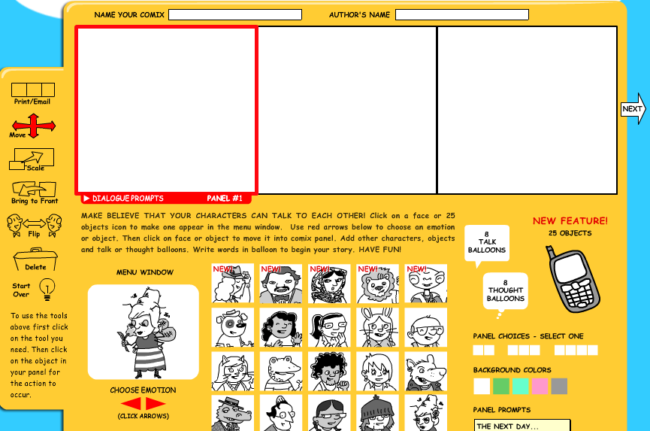

              - 4) Choose a character
              - 5) Pick their emotion
              - 6) Click on their picture and they will insert in panel #1

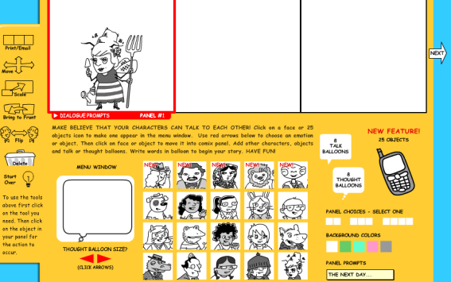
7) To add text boxes click on the balloons
8) Change size of the balloons by using the red arrows
9) Click on the balloon once you want it inserted in panel
10) Drag the balloon to wherever you want it
11) Type in your text
12) Delete by using the trash bin on the side
13) Click on the second panel and repeat process
14) When finished press the print/email on the top left hand side

What do all these pictures do?

Printer will take you to ===
Comics with blank balloons

Select Balloons to insert click on the cell phone to insert objects

Change the number of panels

Change the color of panels

Tips:
There is not away to save so be sure students print or take screen shots when they are done
There isn’t a way to see more than 3 panels at a time
If one presses start over everything is deleted.

