Pic-Lit Step by Step Guide
1. Visit the following website:
http://www.piclits.com/compose_dragdrop.aspx
2. Click on "sign up"
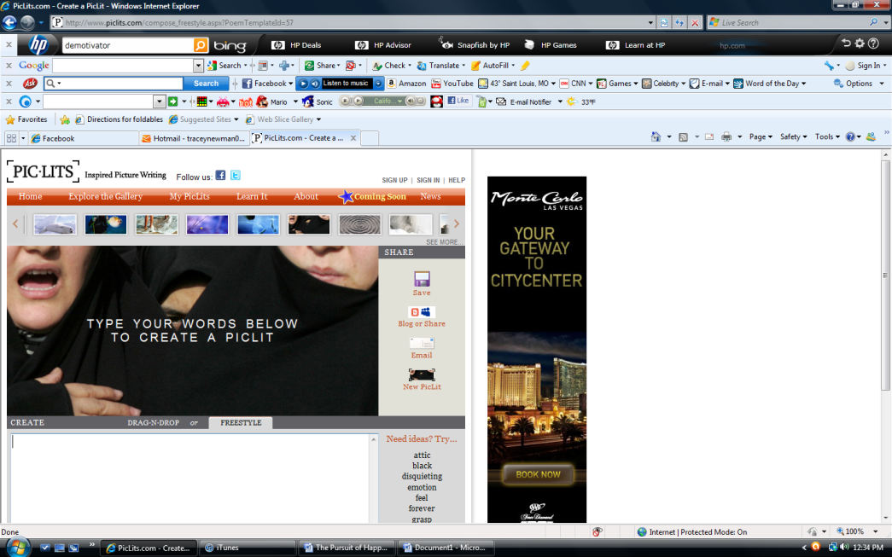
3. Follow the directions to create an account.
4. Choose "Freestyle"
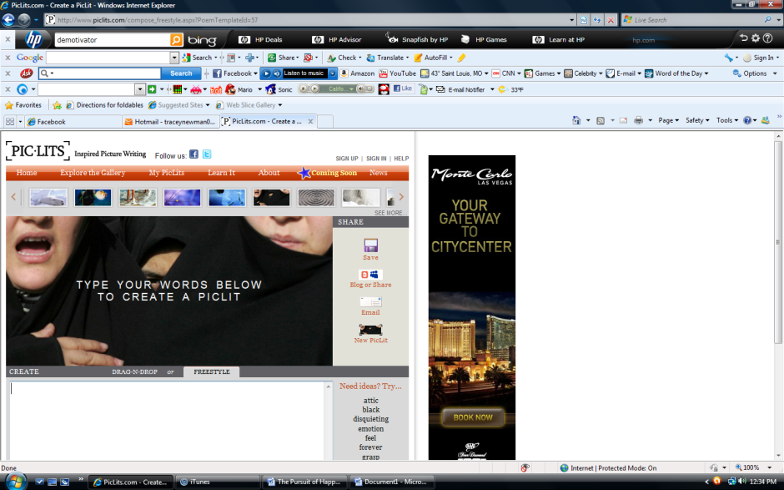
5. Choose a photo from the gallery at the top and click on it. This will become the background for your Pic-Lit.
6. Type the text in the box.
7. Click "Save" when you have finished.

Teaching tips:
In order to arrange the words, use spaces and the enter key
The finished Pic-Lit can be published on a blog or website by clicking the "share" button and following the directions for copying and pasting the code onto another site
Another option is to have the Pic-Lit emailed to the teacher for evaluating

