www.polleverywhere.com

How to create a “free” account
- Go to www.polleverywhere.com
- Click on Sign Up in the upper right hand corner
- A pop screen will appear that will ask for your email (username) and a desired password
- Remember to put these somewhere so you remember them
- Congratulations you can now make polls

How to create Polls
- Log in to www.polleverywhere.com with the account you have created above
- Choose whether you want a multiple choice or a free text question
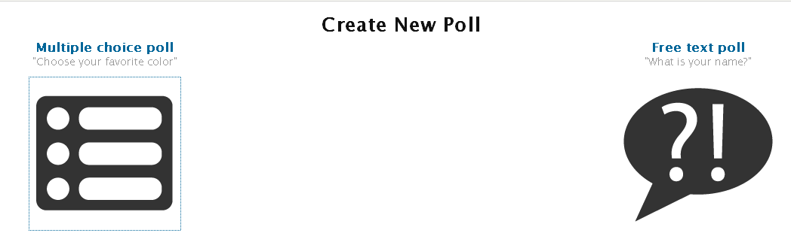

Free Text Poll
- Click on the ? symbol
- Type in your question
- Click on

When answering a “free text” poll the number they text to is 22333 but the body of their message starts with the code given in the poll.
Multiple Choice
- Click on the box
- Insert the question you would like to be answered
- Type in the options you would like available
If you would like more than 3 options click on
- Click on

After completing one of the above and clicking “Save New Poll” a new screen pops up
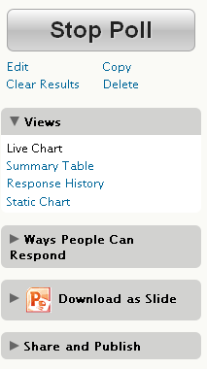
This screen allows you to accomplish the delivery of the poll

The right hand ribbon helps with all aspects of what to do
With the free account only 30 people can respond to a poll;
“clear results” allows the poll to be used several times

How can people vote (Click here to select):
- Via text message
- Via computer
- Twitter
- Smart Phone

The Poll can be delivered several ways:
- Just open the website
- Download as a PowerPoint slide(s)
- Embed in a website or blog, Facebook or Tweet

Tips:
- Hover over the right hand corner of your question to change the settings (font size & colors)
- Have students put the number 22333 in their address book as that is the number for all polls
- The FAQ’s are useful
- With the free account there is NOT a way to track who responded so it can’t be used as a grade
- To help with classroom management have students put their initials at the end of their text
- The PowerPoint that can be downloaded has step by step instructions for voting
- There is an education account that allows a person to poll 35 people for free

