Using Wallwisher in class
1) visit www.wallwisher.com
2) click on "register"
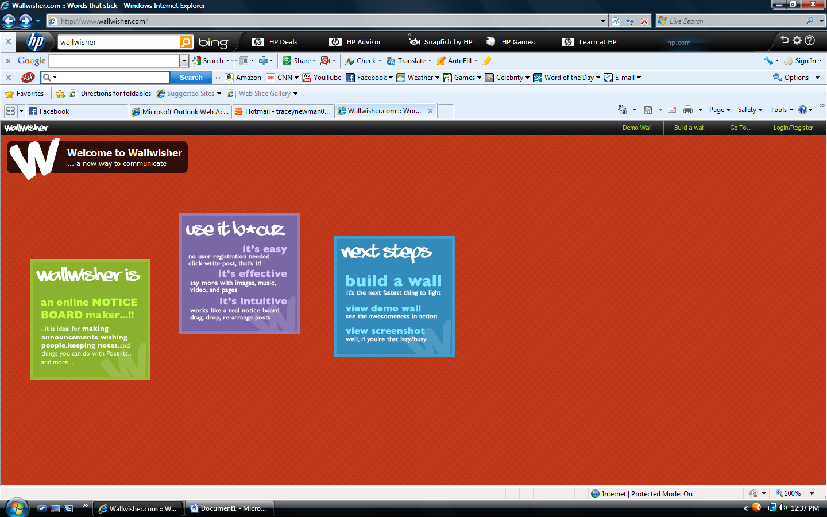
3) click on "build a new wall"
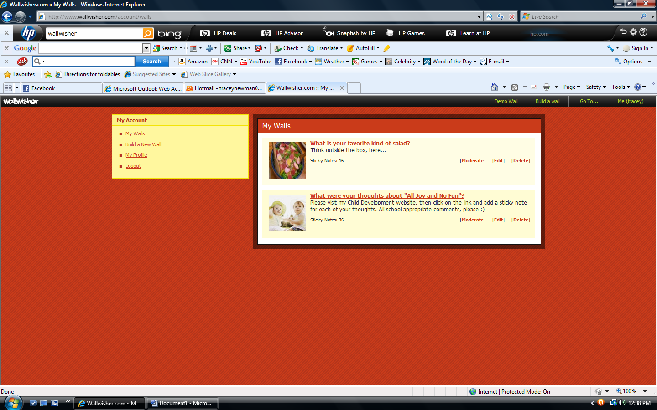

4) Click in the text box in the upper left corner to change the title and/or subtitle.
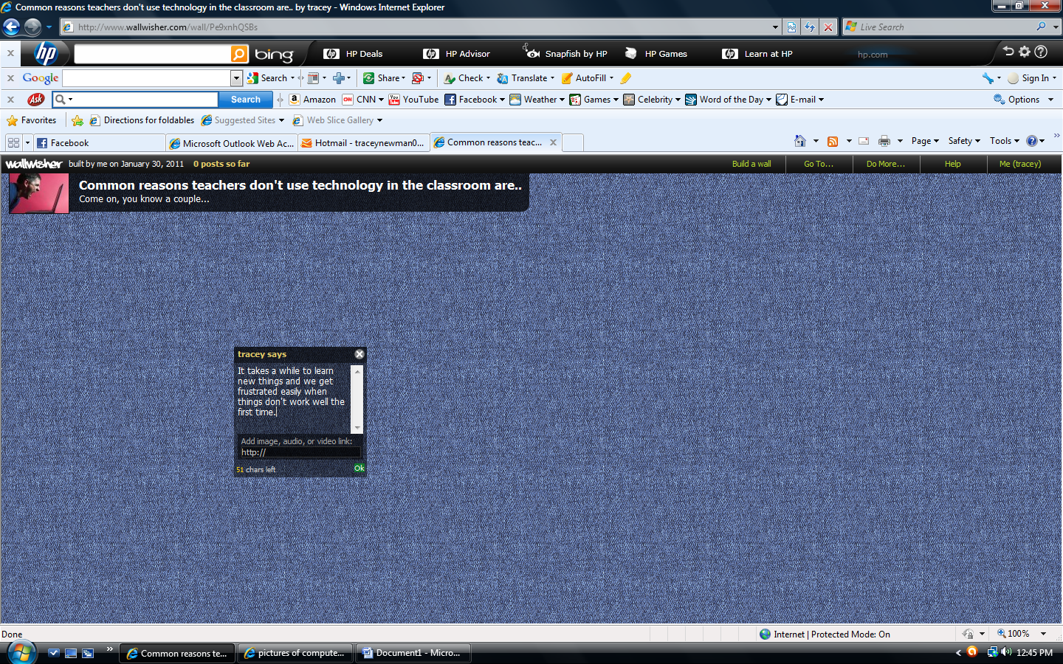
5) Choose the background.
6) Choose the security controls. There are many options, including approving every post and for who is allowed to post.
7)Click "done"
8) Wait patiently and the wall will load.
9) At this point, copy the web address from the bar in the top and instruct participants to visit that site, then click anywhere on the background to add their comments.
10) The characters are limited and other options for uploading include adding files.
11) Click "done" when finished typing the comment.
12) To remove any comments, simply click on the x. 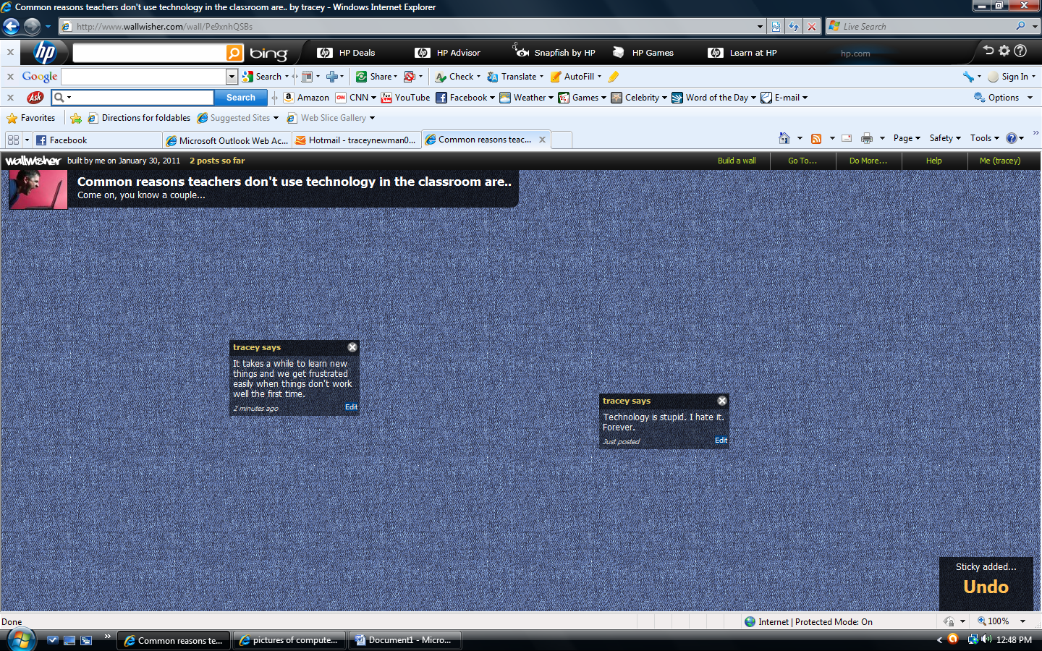

Some comments will not have names...those are people without an account. No account is required to post to the wall.

