Xtimeline Cheat Sheet

- Go to www.xtimeline.com
- Create an account (remember you password )
  - Do this by clicking on sign up in the upper right hand corner
- Once logged in click on “create a timeline”

- A new screen will appear in which the creator is to type in name of timeline and more
- Fill out the appropriate boxes (an image is not necessary)
- Click on create at the bottom of the screen
- A new screen will appear
- Click on “+ add event”
- A new screen will pop up
- Type in the appropriate information for the first date on your timeline
- Students have the option to embed or upload images, add a description and cite a source
  - A description must be entered to continue
- Once a timeline fact is entered press “save and add next”
- When finished entering all timeline facts press save
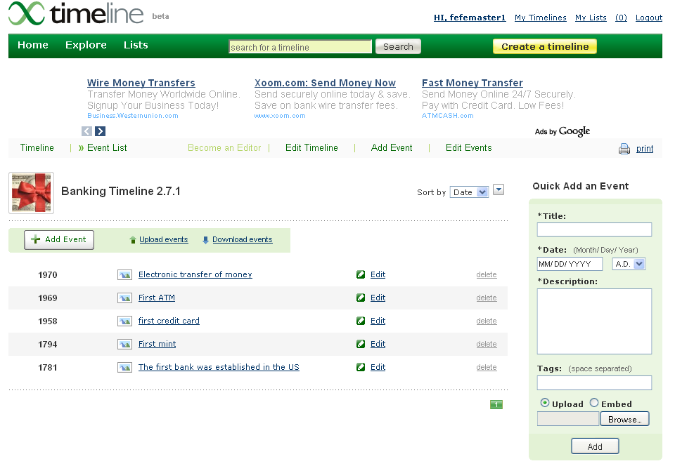
- What appears is a list of all entered dates that looks like below

- From here press on “Timeline”
- What appears is a presentation
- Click on the different dates to view

- Or back go back to “Event List”
- And click on each event
- A PowerPoint like presentation will appear
- Congratulations you have made an interactive Timeline!

